44.32: a) Using the definition of from Example 44.9 we have that
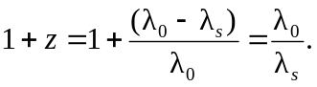
Now we use Eq. 44.13 to obtain
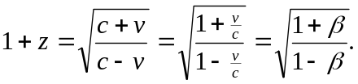
b) Solving the above equation for  we obtain
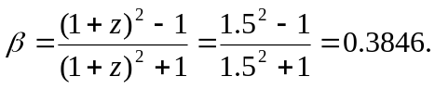
Thus, 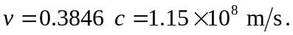
c) We can use Eq. 44.15 to find the distance to the given galaxy,
